Fearn Project
31 Grove Ave NW

Proposed Windows
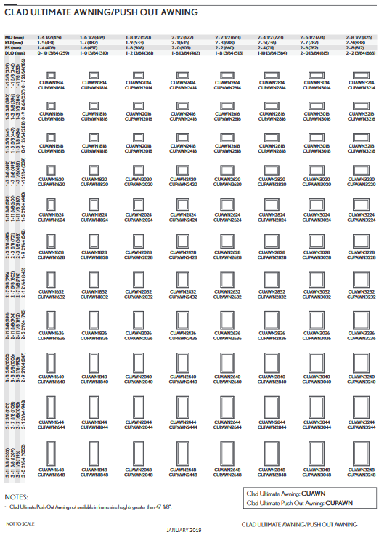

Using CUAWN2424 Awning and Fixed. Also using CUFX2414 Fixed (Not shown here).

Using 1-11/16” IG ADL mullion to create a true horizontal at the midpoint of the window to match the look of the double-hung windows in the house.
(See detail page.)

Fearn Project
31 Grove Ave NW

Proposed Windows
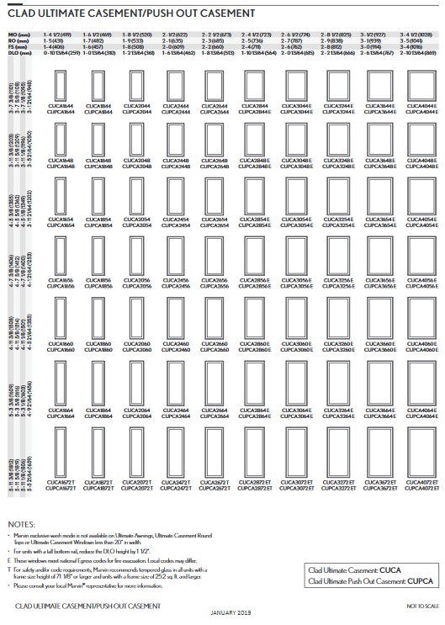
Using CUCA3248 E Casement and CUCA2448 Casement. These windows will provide a low-maintenance solution while maintaining a similar look to the main house windows.
Fearn Project
31 Grove Ave NW

Proposed Window Details

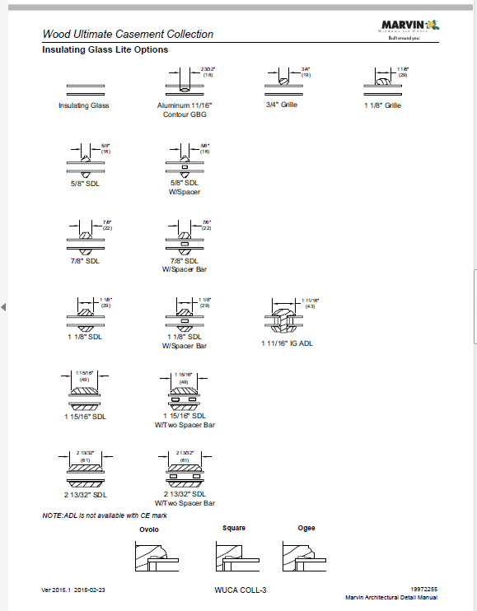

Fearn Project
31 Grove Ave NW

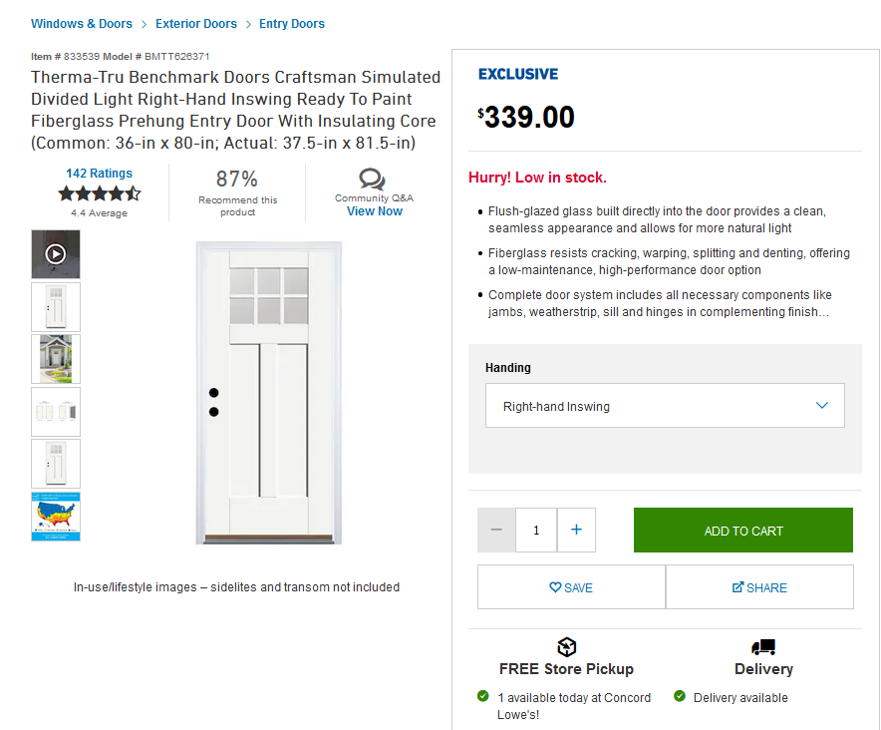
Front and Rear Doors.

All other exterior materials will be wood to match the existing surrounding materials. The intent is to align the new windows with the 2-over-2 windows of the house. A raised-seam, metal roof will be installed on the dormer addition and the new awning roofs. Color to be determined by owner.

As a relatively new (Circa 2015), non-contributing structure, the intention is to not match the detailing of the main house explicitly.
Fearn Project
31 Grove Ave NW

Backyard Pavers by Techo-Bloc
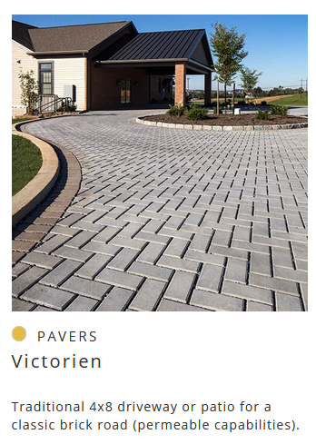
Driveway Expansion by StandarTpark with crushed stone base and pea-gravel infill.
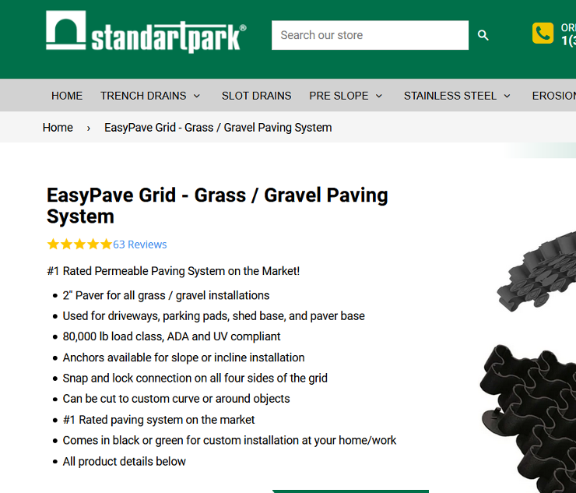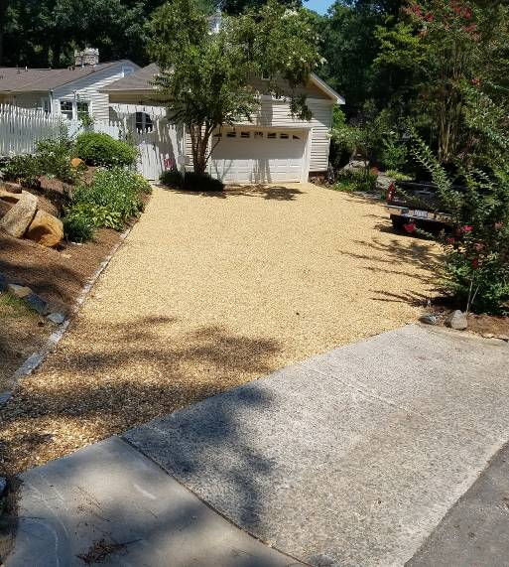

Fearn Project
31 Grove Ave NW

Existing Garage: View from Street
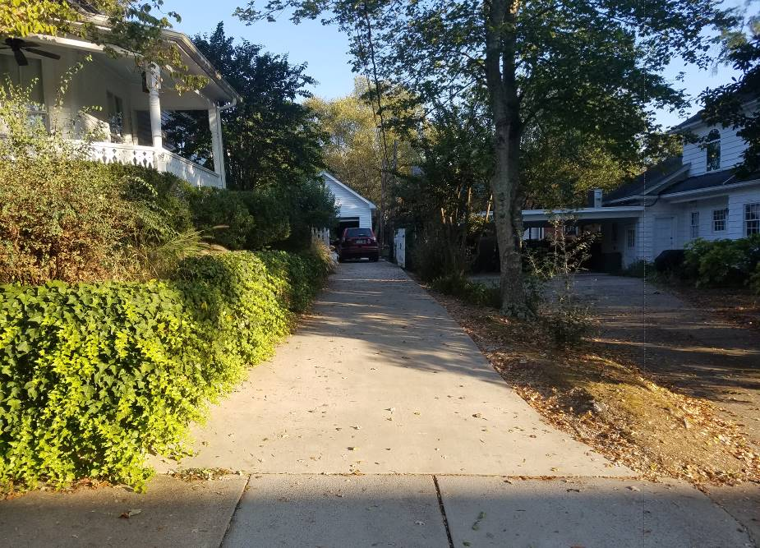

View from Back Yard
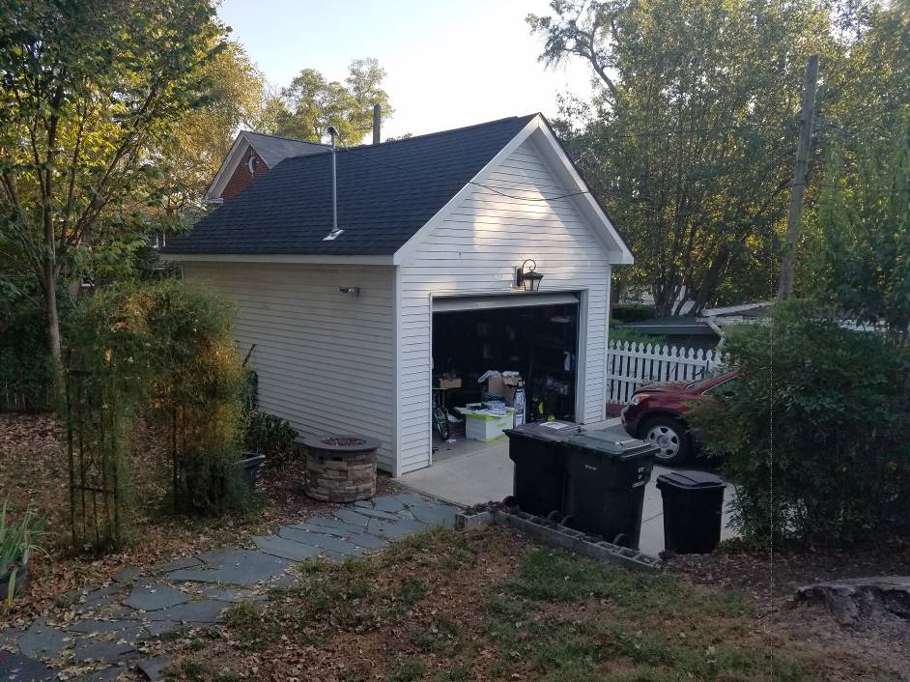

Fearn Project
31 Grove Ave NW

View of Back Yard from Deck
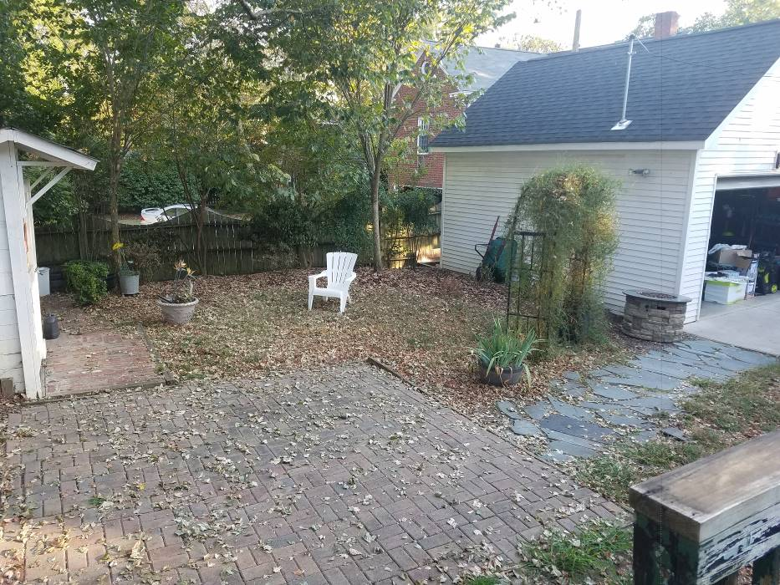

View of Back Yard from Back of Lot
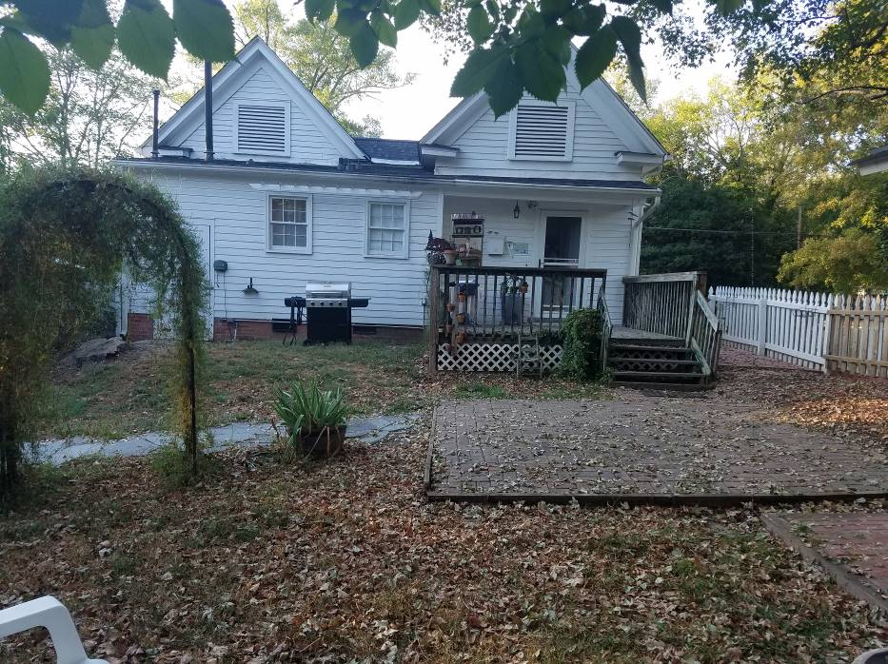

Fearn Project
31 Grove Ave NW

Street View of House



